Greedy approach

1.Meaning
A greedy method keeps picking the most promising move available right now and never goes back to revise earlier picks.
It succeeds when:
- a best immediate step can be extended to a best final answer
- the remaining portion of the task has the same nature as the original

2. Where it is useful
You will often see it in:
- scheduling and intervals
- distributing resources
- rearranging items after sorting
- graph building
- repeated selection of min or max

3. Strengths
- short and clean implementations
- fast execution, commonly linear or n log n
- minimal memory usage
- easier to explain during interviews

4. Spotting opportunities
Hints that usually signal this direction:
- maximize or minimize something
- sorting unlocks a clear order
- an early decision obviously dominates later ones
- dynamic programming feels unnecessary
Typical plan
- Arrange items by priority.
- Decide the rule for choosing.
- Validate why the rule is safe.
- Sweep once while maintaining the choice.

5. Frequent patterns
A. Sort then sweep
Order by end time, profit, height, etc.
B. Interval handling
Accept or discard ranges based on overlap.
C. Running reach or capacity
Track the farthest possible progress.
D. Priority structure
Use heap or counter to always pick the best candidate.

6. Visual intuition of greedy choice
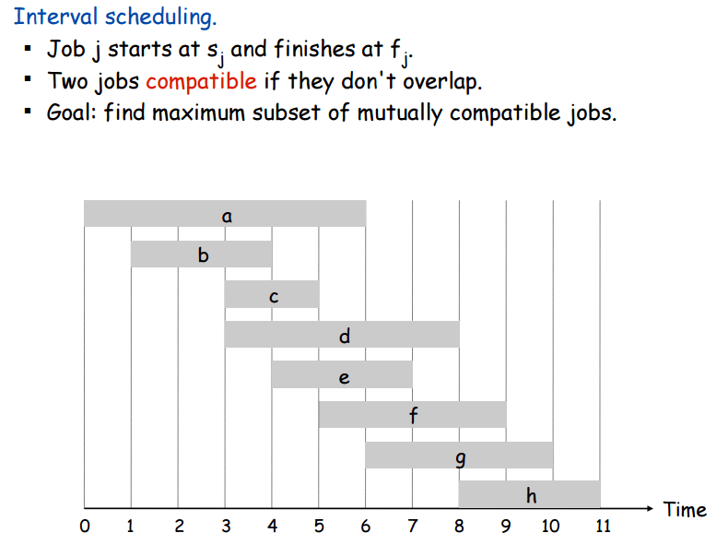
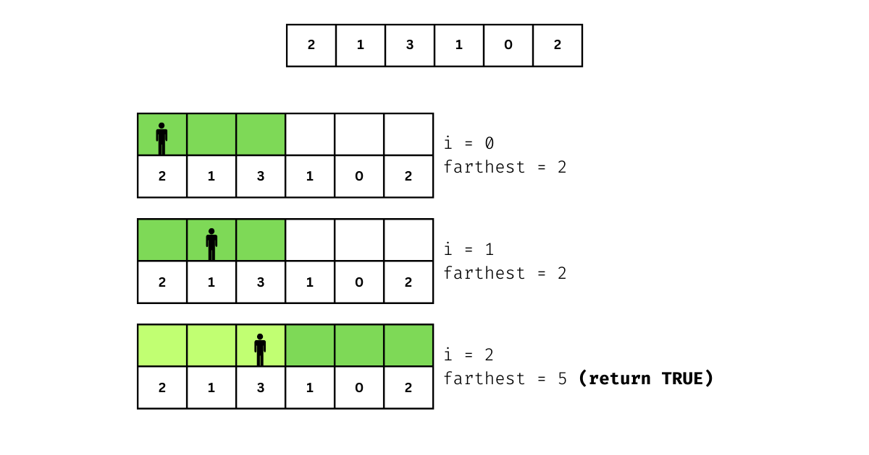
4
The idea is always the same: commit to a decision, shrink the problem, repeat.

7. Practice set by difficulty with numbers
Easy
- Assign Cookies → 455
- Lemonade Change → 860
Medium
- Jump Game → 55
- Gas Station → 134
- Queue Reconstruction by Height → 406
- Reorganize String → 767
Medium to Hard
- Task Scheduler → 621
- Non overlapping Intervals → 435
- Minimum Arrows to Burst Balloons → 452

